El Paso Master Script Upgrade

## Summary

Accela has upgraded the agency scripts from 1.x and 2.x formats to the newest scripting 3.0 format. The scripts have been moved out of standard choices and into JavaScript files, using the Accela best practice directory structure. The standard choices have been converted to a structure that mirrors the record type structure for the agency. This document describes the details of the conversion.

## Document Control

| Date | Author | Version | Change Reference |
| --- | --- | --- | --- |
|  |  |  |  |
| 2/21/2016 | John Schomp | 1.0 | Initial |
|  |  |  |  |
|  |  |  |  |
|  |  |  |  |

## Analysis

The current scripts in use are a mix of Master Script version 1.5, 1.6, and 2.0 distributions. The scripts were analyzed and minor variations were found from the original distribution. These variations were primarily newly defined functions. The distribution package included with this document has accounted for these differences through the use of the INCLUDES_CUSTOM script directory.

A review of the scripting shows that customary standards for scripting based on version 1.6 have been used. “Variable branching” was used in many cases.

## Conversion Details

* To assist with testing, the original “Branch” standard choice names have been added as comments to the converted scripts. Once testing is complete these comments won’t be needed.
* The conversion algorithm has created some instances where double sets of braces {{ … }} denote a code block. These can be removed if desired, but they have no impact on the script execution.
* Many scripts were placeholders for future scripts and performed no actions. These have been removed in order to simplify the working codeset.

* There are many Standard Choices that were referenced but did not exist in the system. These calls were removed in order to simplify the working codeset.
* All references to setting both showDebug and showMessage to false as this is the default setting of master scripts.
* There were many references to conditionally setting debugging based on user ID. These have been removed in most cases in order to simplify the scripts. Accela recommends setting this in one place, preferably using INCLUDES_CUSTOM_GLOBALS for this purpose. For example: if (matches(currentUserID, 'cr2141', 'CR2141', 'bw0944', 'dl2424', 'BW0944', 'DL2424')) { showDebug = 3; showMessage = false; }
* When requesting debugging (showDebug = true) you should set showMessage equal to false in order to get the proper results.
* References to unconditionally setting showDebug and/or showMessage to true have been left in the code.

* All script files have been formatted to JavaScript standards for indentation.
* “if (false)” code has been removed and converted to comments.
* Several events had code framework configured but no business logic. These have been removed. For optimal performance, Accela recommends enabling events that are required to apply business logic. Events used are: ASA, ASB, ASIUA, ASUA, CTRCA, FAA, IRSA, ISA, ISB, PRA, PRB, RIUA, WTUA, WTUB
* WorkflowTaskUpdateAfter-GND contained illegal quote characters, possibly a bad paste from a Microsoft Word document or email. These have been fixed.

## Recommendations

Some recommendations on the existing code are as follows:

* There are script lines used to create outgoing emails. There is new email template functionality that can be used which would make management of these emails much easier. See the V360 Admin -> Notification Template feature for more information. The number of scripts used to send these emails could be dramatically reduced.
* Review/Edit all TODO sections as shown below:

|  |
| --- |
| \Scripts\Event\ASA;AMS!ESD!CONTAINERS!NA.JS (1 hit)  Line 41: // TODO: Branch doesn't exist  \Scripts\Event\ASA;ANIMAL!~!~!~.JS (1 hit)  Line 9: // TODO: branch doesn't exist  \Scripts\Event\WTUA;ANIMAL!ANIMAL!NA!NA.JS (1 hit)  Line 3: // TODO: branch does not exist  \Scripts\Event\WTUA;BUILDING!FENCES!NA!NA.JS (1 hit)  Line 7: // TODO: branch doesn't exist  \Scripts\Event\WTUA;BUILDING!RESIDENTIAL!NEW!NA.JS (1 hit)  Line 7: // TODO: branch doesn't exist |

## Script Repository

The master script 3.0 deployment for El Paso is located in a cloud based Subversion repository, using [www.assembla.com](http://www.assembla.com) as a temporary repository. The credentials and URLs for the repository are shown below.

|  |  |
| --- | --- |
| Repository Site | [www.assembla.com](http://www.assembla.com) |
| Repository URL | https://subversion.assembla.com/svn/slcscripts/TEST |
| Username | slcScripts |
| Password | Ay6fLVszW2gb49D8HhRa |

Note: This repository is intended only for the purpose of managing the migration of the converted scripts. Once this project is over, El Paso will be responsible for maintain their own repository, if desired.

To connect to the repository, the “EMSEToolConfig” standard choice will need to be configured as in the screenshot below.

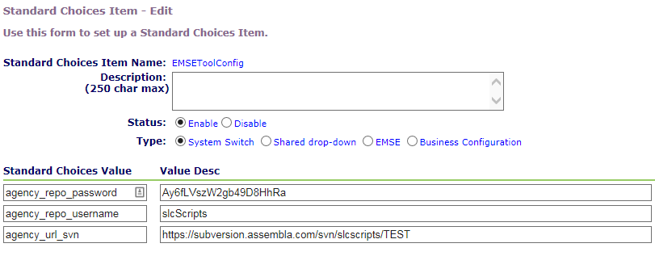

Once added, the “EMSETool” portlet can be added to an administrator console. When the EMSETool portlet is opened, the following will display:

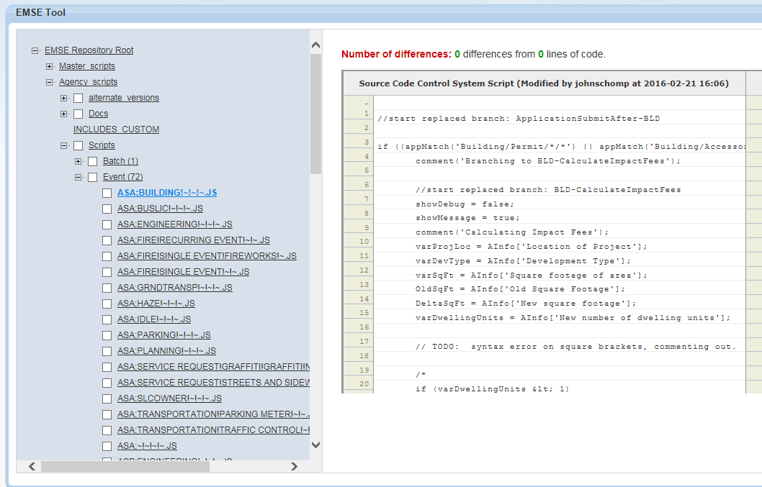

## Standard Choices

The following Standard Choices need to be configured. These are documented in the Master Script distribution in the documentation folder.

* EMSE_EXECUTE_OPTIONS determines if Scripts or Standard Choices, or both should be executed by the master script.
* EMSE_VARIABLE_BRANCH_PREFIX determines the naming convention used to determine if a script is associated to a particular event.

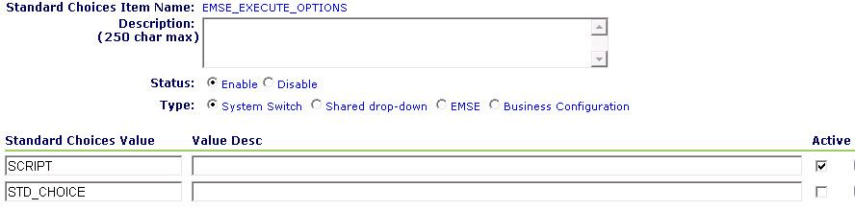

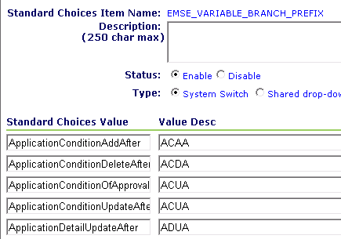

## Repository Contents

* Docs: This document
* Agency Scripts: These are the El Paso scripts that have been converted from standard choices into pure JavaScript.
  + Event: These are the event scripts that were previously stored in standard choices
  + INCLUDES_CUSTOM: These are custom functions that were previously appended to the agency’s master scripts. In addition, several custom functions were added that have been converted from standard choices. Only standard choices that were called from multiple locations have been converted to functions.